|  |  |
| --- | --- |
| NavVision Operators Manual | |
| Automation Competence Center | |
|  |  |

|  |  |
| --- | --- |
| Publication type: | NavVision Operators Manual |
| Publication number: | ACC |
| Title: | ACC-NavVision-Operators-Manual v2.1.1 |
| Subject: | Automation Competence Center |
| Issue: | 2.1.1 |
| Publication date: | 16 December 2014 |
| Total number of pages: | 54 |
| Author: | Vince Kerckhaert |
| Quality Control: | Max Steenbergen |

Table of contents

Page #

Figures 4

Tables 5

References 7

Introduction 8

About the Operating Manual 8

Safety instructions 10

Revision history 10

1. Human Machine Interface 11

1.1 Taskbar 11

1.1.1 User rights 12

1.1.2 Palette 13

1.1.3 Mimics 13

1.1.3.1 Mimics 14

1.1.3.2 General 14

1.1.3.3 Mimic examples 14

1.1.3.4 Reading the mimic 15

1.1.4 Logbook 17

1.1.4.1 Logbook groups 17

1.1.4.2 Logbook appearance 18

1.1.4.3 Logbook status indication 18

1.1.4.4 Logbook search bar and buttons 19

1.1.5 Group viewer 21

1.1.5.1 The search bar 22

1.1.6 Settings 23

1.1.7 Alarm Mimic 24

1.1.7.1 Alarm icons 25

2. Alarm System 27

2.1 Introduction 27

2.2 Alarm handling 27

2.3 Alarm handling in the alarm mimic 29

2.3.1 Explanation of alarm rights 29

2.4 Duty alarm system 30

2.4.1 Extra buttons alarm mimic 33

2.4.2 Duty alarm principal 36

2.4.3 Alarm types 36

2.4.3.1 Alarm detection for analogue signals 36

2.4.3.2 Alarm detection for on/off (two state) signals 36

2.4.3.3 Alarm detection for on/off signals with line check 37

2.4.4 Attended alarm mode 37

2.4.5 Unattended alarm mode 37

2.4.6 How to acknowledge an alarm 38

2.4.7 How to silence an alarm (not at ECR) 38

2.4.8 When will an alarm disappear 38

3. Personnel alarm 38

3.1 Engineer Deadman 38

3.1.1 Scope 38

3.1.2 The Engineer Deadman System incorporates the following operational modes: 38

3.1.3 Operational State 39

3.1.4 Reset function 39

3.1.5 Emergency call facility 39

3.2 BNWAS 40

3.2.1 Introduction 40

3.2.2 The HMI overview 40

3.2.3 The HMI explained 41

3.2.4 The setup page 43

4. Annex 1 Mimic control 47

4.1 Mimic components 47

4.2 Component behaviour 49

Figures

Figure 1‑1: NavVision taskbar 11

Figure 1‑2: User selection 12

Figure 1‑3: Palette options 13

Figure 1‑4: Mimic menu 14

Figure 1‑5: Mimic example 1 15

Figure 1‑6: Legend mimic 15

Figure 1‑7: Tank mimic 16

Figure 1‑8: Alarm list and logbook in mimic 16

Figure 1‑9: logging groups, all selected 17

Figure 1‑10: interconnecting log appearance 18

Figure 1‑11: Status indication log-entries 18

Figure 1‑12: Logging colors 19

Figure 1‑13: Logbook search bar and buttons 19

Figure 1‑14: Search calendar 20

Figure 1‑15: Print button 20

Figure 1‑16: Up- down buttons 20

Figure 1‑17: Group viewer 21

Figure 1‑18: Group Viewer columns 22

Figure 1‑19: Search bar 22

Figure 1‑20: Alarm groups 22

Figure 1‑21: Categories group 23

Figure 1‑22: Categories subgroup 23

Figure 1‑23: Group viewer in alarm 23

Figure 1‑24: Group viewer mimic and I/O location 23

Figure 1‑25: Alarm mimic 24

Figure 1‑26: Print button 26

Figure 1‑27: Up- down buttons 26

Figure 2‑1: typical alarm sequence 28

Figure 2‑2: Alarm group row 29

Figure 2‑3: silence/acknowledge-button 29

Figure 2‑4: typical Alarm panels 30

Figure 2‑5: Typical DAP screen 33

Figure 2‑6: Bridge set-up icons 33

Figure 2‑7: ER set-up icons 33

Figure 2‑8: Call function 35

Figure 2‑9: Duty select function 35

Figure 2‑10: receiving call message 35

Figure 2‑11: Crew information 36

Figure 3‑1: Password entrance panel 39

Figure 3‑2: Main BNWAS HMI 40

Figure 3‑3: HMI top bar 41

Figure 3‑4: HMI main screen 41

Figure 3‑5: HMI bottom bar 42

Figure 3‑6: HMI Panel 42

Figure 3‑7: Setup screen 43

Figure 3‑8: Keypad 44

Figure 3‑9: Setup main screen 44

Figure 3‑10: NavVision HMI on DAP 45

Figure 3‑11: NavVision Native screen 46

Figure 4‑1: Pop-up balloon 49

Figure 4‑2: control doughnut 50

Figure 4‑3: Vertical bar with alarm lines 50

Figure 4‑4: Edit keyboard 51

# Tables

Table 1: NavVision taskbar 11

Table 2: Logging groups 17

Table 3: Logbook colors 19

Table 4: Group Viewer columns 22

Table 5: Alarm Icons 26

Table 6: Alarm panel buttons 32

Table 7: Alarm mimic set-up icons 34

Table 8: Control element status 51

Table 9: Control elements and color animation 52

Table 10: Control elements with status indication 53

Table 11: Control elements with speed indication 54

Table 12: Other control elements 54

**NOTICE**

**This document contains proprietary information.**

**No part of this document may be photocopied, reproduced or translated into another language without the prior written consent of   
Imtech B.V.**

References

Not applicable.

Introduction

This Operating Manual contains all essential information for the user to make full use of FT NavVision. This manual includes a description of the alarm functions, monitoring functions, control functions and additional capabilities. Also described are contingencies and alternate modes of operation, as well as step-by-step procedures for system access and use.

About the Operating Manual

This manual contains the following sections:

* *Safety instructions* presents warning, caution and note information, which the user should pay attention to;
* *Human Machine Interface* contains explanation on the look and feel of the visible part of FT NavVision;
* *Duty Alarm System* explains how to work with the AM(C)S system and how the different parts are integrated in FT NavVision
* *Personnel Alarm* explains the workflow of the various Deadman systems across FT NavVision.
* *Mimics* shows how to work with the various interactive possibilities within FT NavVision’s mimics.

For specific information on interfaces, but also in depth information on features, mentioned here or not, we refer you to their specific manuals which can be obtained through Imtech.Abbreviations list

**AM(C)S** Alarm Monitoring (& Control) System

**COM**  Communication

**CPU**  Central Processing Unit

**DAP** Duty Alarm panel

**DM** Dead Man’s

**ECR** Engine Control Room

**GEA** General Engineers Alarm

**GPS** Global Positioning System

**GRP** Group

**ID** Identification

**I/O** Input/Output

**LAN** Local Area Network

**LED** Light Emitting Diode

**LPU** Local Processing Unit

**MAC** Media Access Control

**NMEA** National Marine Electronics Association

**OWS**  Operator Work Station

**SMS**  Short Message Service

**TCP/IP** Transmission Control Protocol/ Internet Protocol

**TFT** Thin Film Transistor

**USB** Universal Serial Bus

Safety instructions

* This section provides only a summary of the safety requirements and notes in the following sections. To protect your health and prevent damage to the AM(C)S equipment or vessel, it is essential to read and carefully follow the safety instructions.*

The indications NOTE, CAUTION and WARNING have the following significance:



*NOTE:  
An operating procedure, practice or condition etc., which it is important to emphasize.*

**

*CAUTION:*

*An operating procedure, practise or condition etc., which, if not strictly observed, may damage AM(C)S equipment or crash NavVision software.*

* WARNING:*

*An operating procedure, practise or condition etc., which, if not carefully observed may result in personal injury or damage to the vessel.*

Revision history

Revisions issued since publication.

|  |  |  |  |
| --- | --- | --- | --- |
| **Issue** | **Date** | **Revision** | **Reason** |
| 2.1.1 | September 09, 2014 | New version | Decimus update |

# Human Machine Interface

The FT NavVision *Human Machine Interface* (HMI) displays the current state of any physical device (I/O) on one or more monitor screen(s) by color, animation or values.

Moreover, when an undesirable state of a device is detected the operator will be notified by means of an audible and/or visible alarm signal. Messages concerning the alarm are added to the FT NavVision list of active or unacknowledged alarms (*Alarm Page*). This list can be displayed by clicking the Imtech logo in the center of the taskbar.

The HMI also supports remote platform control. Operators can control the platform (vessel) via the HMI.

## Taskbar

NavVision’s main User Interface (UI) element is the taskbar, positioned on top of each screen. The taskbar is home to the shortcuts to various settings, modules and mimics.

In addition, when an alarm is registered, the middle portion of the taskbar turns a bright red and shows the most recent unacknowledged alarm, the number of active alarms, and the total number of unacknowledged alarms. A single mouse click on this portion of the taskbar links to the extensive alarm viewer, showing the data for each active alarm such as time, alarm group, status and duration.

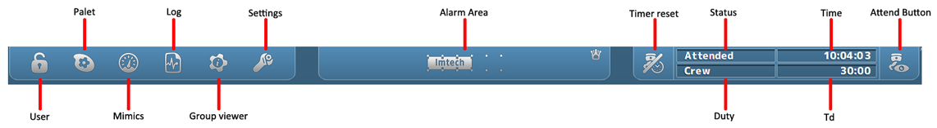

Figure 1‑1: NavVision taskbar

|  |  |
| --- | --- |
| **Takbar Icon** | **Explanation** |
| User | Setting of user and user rights |
| Palette | Setting of colors and day, dusk or night mode |
| Mimics | Selecting the mimics |
| Log | Show the log files |
| Group viewer | Show information on all I/O |
| Settings | Entry to all settings |
| Alarm Area | Click to show/hide alarm mimic |
| Timer Reset | Reset deadman timer, show active/inactive state |
| Status | Show status of attendance of the ER |
| Duty | Show person on duty |
| Time | Time |
| Td | Time dormant (for deadman timer) |
| Attend Button | Attend/unattended button for ER or Bridge |

Table 1: NavVision taskbar

### User rights

FT NavVisionhandles control rights by using log-in credentials (username and password), and assigning rights to these credentials. These rights limit access to the system's configuration, therefore ruling out any edits that may harm the system made by unauthorised crewmembers.

Users can be added, edited or removed. Adding, editing and removing users, together with assigning their rights, can only be done by an administrator, i.e. a top-level user.

For every profile made, permissions can be set. The system is delivered with three pre-configured user-profiles, namely:

1. *Administrator*: has all rights;
2. *Guest*: can only use the available viewers;
3. *Operator*: can only alter display mode and/or units.

Login is required upon system start-up. After start-up, users can log off and log in using the dedicated button on the taskbar. By clicking the button, the following window will appear:

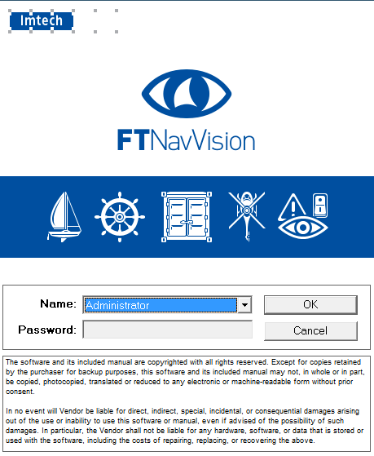

Figure 1‑2: User selection

By clicking the drop-down menu “Name”, you can choose which user you want to start. Provide the password if necessary and click “OK”.

### Palette

The palette is meant to give a quick selection to change the color settings of the screen. When you click the button, you’ll be presented with 4 choices (see Figure 1‑3).

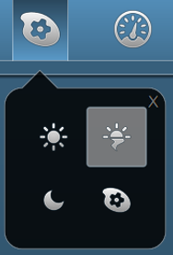

Figure 1‑3: Palette options

From left to right (beginning top left), there are three predefined buttons: Day, Dusk and Night. These choices give you the right colors and brightness for these specific periods of time. The last one is the palette selection tool. Using this, you can change the colors of the three presets to your liking.

* When you change the colors of a preset, be aware that there is no “Default” setting. It might be hard to get the colors back to their old state.*

### Mimics

When you click the mimic button, you’re presented with a grid of mimics available to you. It‘s possible that you have all the mimics as numbers so you have to choose the right number (see Figure 1‑4).

If you know the right number for the mimic you want to see, simply click on the corresponding icon.

Quite often, the only mimic icon that is presented is number one. This is the home mimic. From the home-mimic you can then navigate to other mimics.

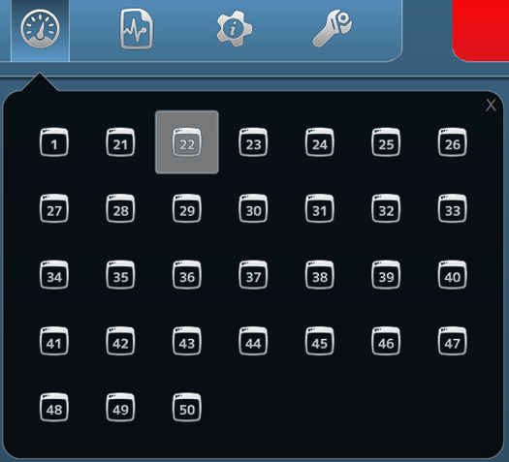

Figure 1‑4: Mimic menu

#### Mimics

The FT NavVision mimic presentation function provides schematic and graphical overviews of the vessel’s systems like navigation lights, electrical, piping and hydraulic overview.

The screens and mimics presentations are automatically updated with live data of the platform components illustrating components and/or system status.

Via these screens and mimic pages, the operator is able to monitor and control the vessel by using the trackball or touch-screen as a pointing device by selecting elements and their associated commands.

#### General

In general, we say that every page that represents a set of values, switches or any other representation of data is a mimic. The mimics within the system are all freely adjustable within the design stage. After the system is delivered, changes can be made by the NavVision engineers, on appointment. Small changes to the mimic can be made by a trained and skilled operator, who is granted some extra rights in the system. This trained crewmember will have the documentation, so we won’t discuss the changing of mimics in this manual.

#### Mimic examples

Although the mimics are freely adjustable, the main setup will be greatly alike on your screen. Imtech has defined some rules that the mimics have to live up to. This results in an overall recognizable style of mimics that gives it the modern and stylish look and feel.

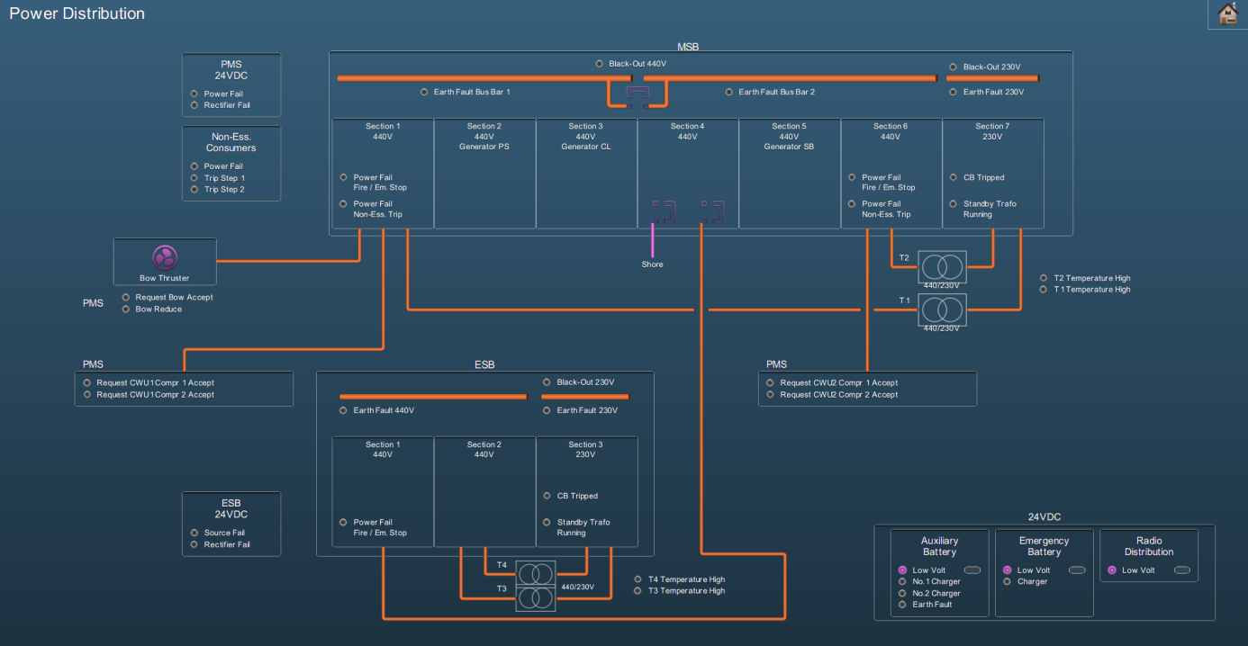

Figure 1‑5: Mimic example 1

#### Reading the mimic

Some installations contain a special *legend* mimic. This mimic explains the symbols, variations, colors etc. that you can find in your system’s mimics (see Figure 1‑6). If there is ever a doubt in what you observe on the mimic you are watching, please refer to this mimic.

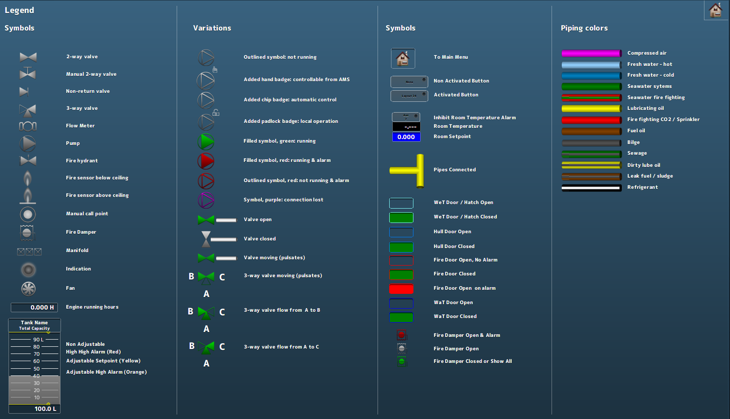

Figure 1‑6: Legend mimic

Other mimics can show a variety of information. There can be mimics for power distribution, tank volumes (see Figure 1‑7), fire alarms and many more. It is also possible that you have a combination of subjects on one mimic. Mimics are perfectly capable of displaying camera feeds or trend graphs.

As a special feature you can show the alarm list or the logbook on (part of) the mimic (see Figure 1‑8).

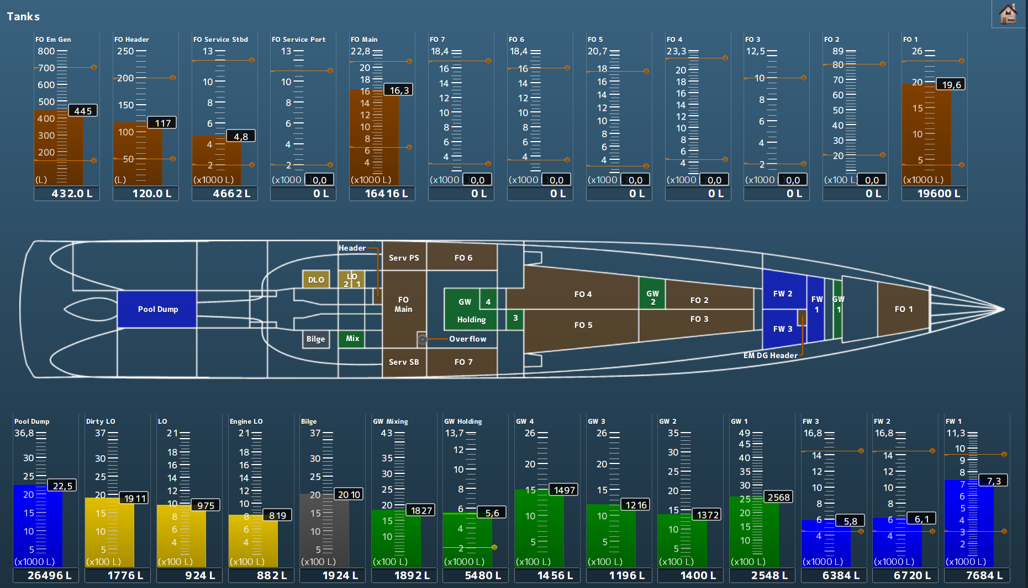

Figure 1‑7: Tank mimic

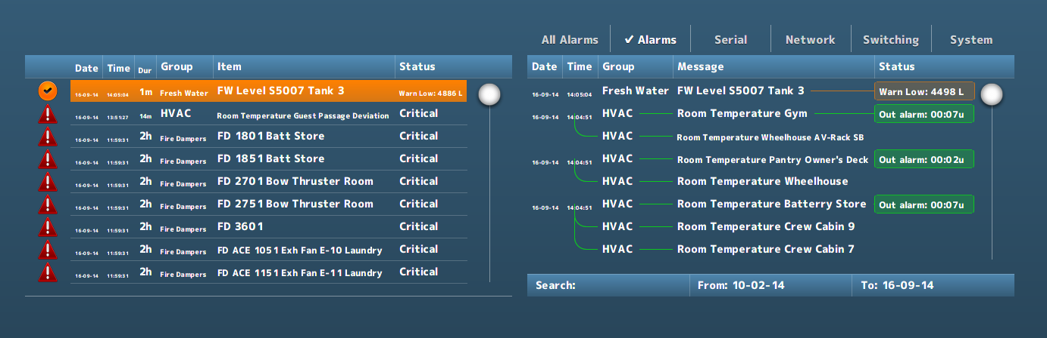

Figure 1‑8: Alarm list and logbook in mimic

*More extensive explanation on control in a mimic can be found in Annex 1 (See Chapter 6, page 47).*

### Logbook

During normal operation, all system events are registered chronologically. By clicking the *Logbook* button (see Figure 1‑1), these registered system events are displayed in a dedicated screen. It is also possible to show the logbook in any mimic (see Figure 1‑8).

#### Logbook groups

In order to separate various categories of information from each other, log entries are stored in various logging-groups. You can select them all or just a few of them, or even one if you need to focus on these entries. Just by selecting the category label at the top of the list, you filter the information you need (see Figure 1‑9).



Figure 1‑9: logging groups, all selected

|  |  |
| --- | --- |
| **Logging group** | **Explanation** |
| All Alarms | Alarms from all stations (even alarms you might not see on this station will be logged) |
| Alarms | All alarms from this station (all alarms that are visible on this station will be logged) |
| Serial | All serial information available on this station will be logged (initializing, finalizing and errors) |
| Network | All network information available on this station will be logged (Connecting, conn. Failed and errors) |
| Switching | All system, network and program switching |
| System | All process information and errors |

Table 2: Logging groups

#### Logbook appearance

All identical log entries that appear at the same time will be interconnected as shown in the following figure (see Figure 1‑10).

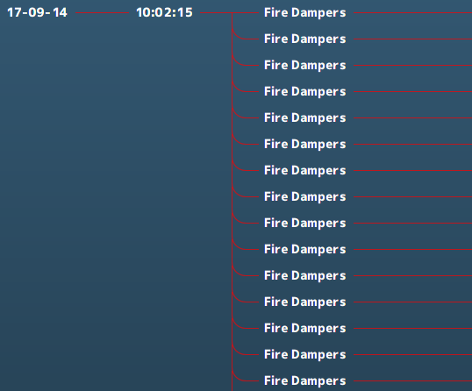

Figure 1‑10: interconnecting log appearance

#### Logbook status indication

All entries will have an explanatory status indication at the end of the entry line. This will give an indication about the reason that the indication is in the logbook (see Figure 1‑11).

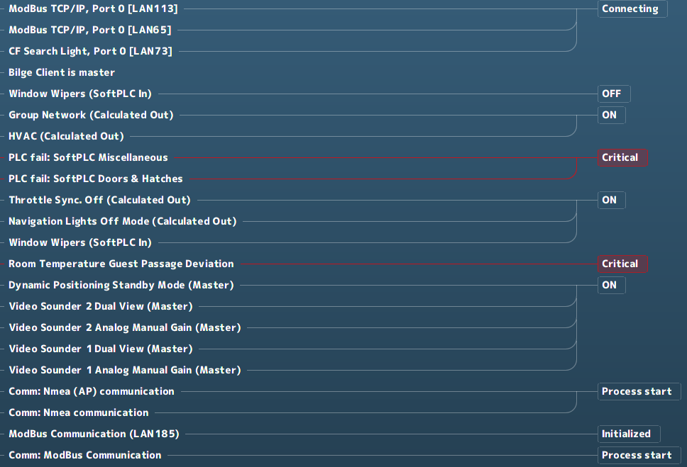

Figure 1‑11: Status indication log-entries

When logging alarms, this status indication will also be colored.

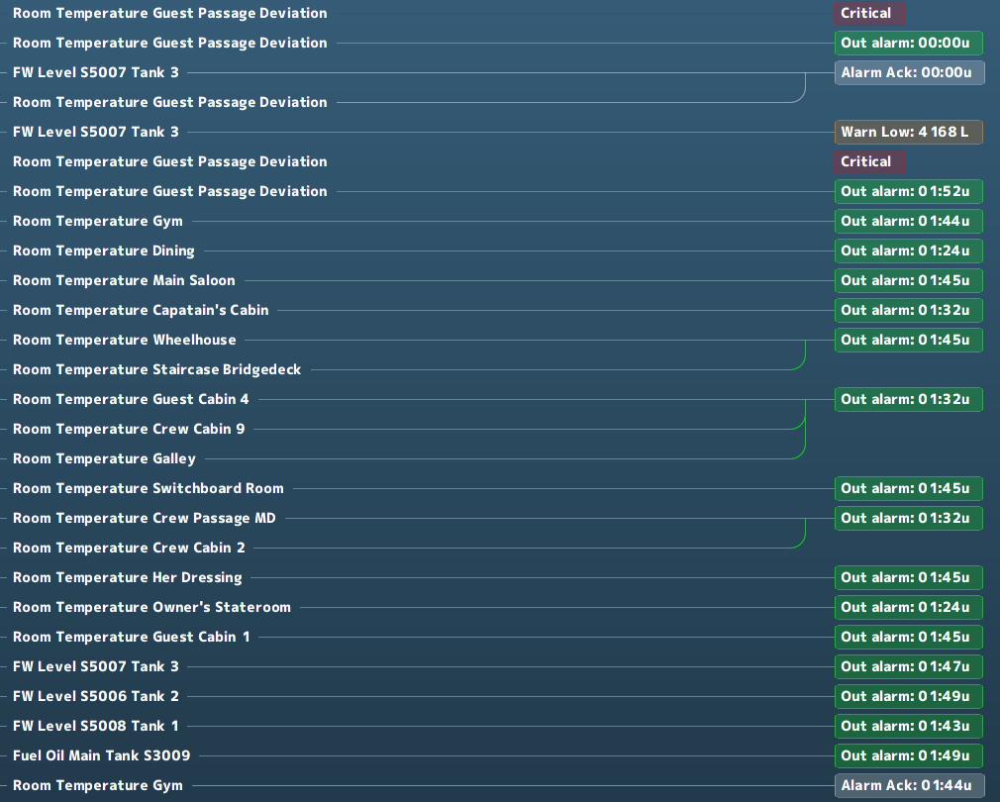

Figure 1‑12: Logging colors

|  |  |
| --- | --- |
| **Logging colors** | **Explanation** |
| Grey | Acknowledged |
| Green | Out of alarm or OK |
| Yellow | Caution |
| Orange | Warning |
| Red | Critical, Slowdown and Shutdown |

Table 3: Logbook colors

#### Logbook search bar and buttons

At the bottom of the logbook, you will find a search bar and a few buttons (see Figure 1‑13). In the search bar, you can click and type the name of the listing you are looking for. After hitting *Enter* the listing is shown, if available.



Figure 1‑13: Logbook search bar and buttons

If you click on the “From:” or “To:” on the search bar, a new window will appear (see Figure 1‑14). This window is a fully working calendar from which you can choose a “From” or “To” date. After you have entered the date and pressed the checkmark, the entries that occurred in the entered timeframe are shown.

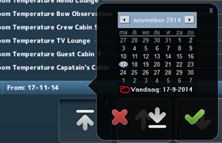

Figure 1‑14: Search calendar



Figure 1‑15: Print button



Figure 1‑16: Up- down buttons

If you click the *Print* button, you can print the logbook (if a printer is available). With the *Up* & *Down* buttons you can scroll to the top, up or down.

### Group viewer

The *Group Viewer* is the place within FT NavVision that holds the necessary information about all connected I/O. In this window, you can find a descriptive line for all the sensors with their connections and dependencies (see Figure 1‑17).

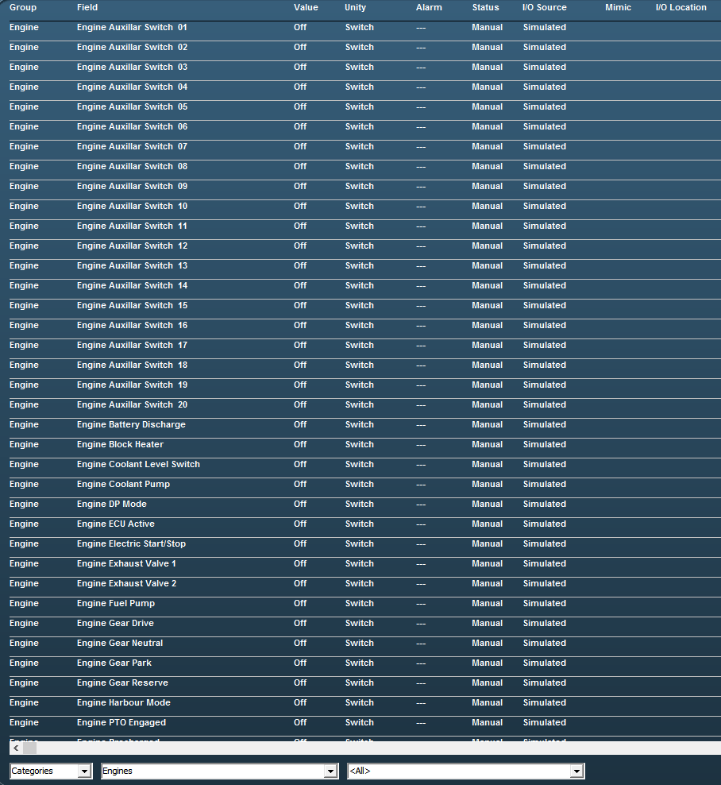

Figure 1‑17: Group viewer

There are various columns that each list a specific piece of metadata of an I/O point in clear language or digits and colors.

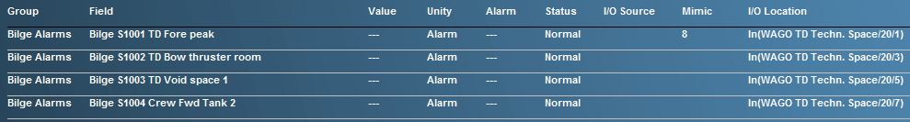

Figure 1‑18: Group Viewer columns

|  |  |
| --- | --- |
| **Column** | **Explanation** |
| Group | The alarm group the I/O point belongs to |
| Field | The item name of the I/O point (FT NavVision ID-tag) |
| Value | Actual value of the I/O point |
| Unity | The Unity of the I/O point |
| Alarm | Shows if the I/O point is in alarm and the value of the alarm |
| Status | Status of the I/O point |
| I/O Source | The source (interface) the I/O point comes from |
| Mimic | The mimic(s) the I/O point value is present |
| I/O Location | The location where you can find the I/O point physically |

Table 4: Group Viewer columns

#### The search bar

Using the search bar, you can reduce the amount of searchable data to a specified group. This way it is easier to pinpoint the faulty I/O point you are looking for (see Figure 1‑19).



Figure 1‑19: Search bar

In the first drop-down menu, you can choose between *Categories* and *Alarm Groups* in which you change between the standard arrangement of categories as set in FT NavVision or the division in alarm groups.

When choosing for *Alarm Groups,* you have the choice to narrow the selection down even further to the specific alarm group that you are looking for (see Figure 1‑20).

When you choose for the *Categories*, you can narrow it down to the group and even subgroup for that particular I/O point (see Figure 1‑21 and Figure 1‑22).

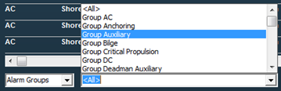

Figure 1‑20: Alarm groups

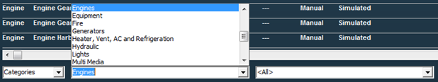

Figure 1‑21: Categories group

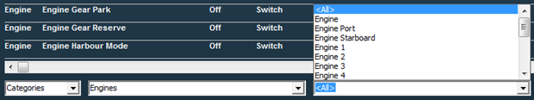

Figure 1‑22: Categories subgroup

If there is an I/O point currently in alarm status, it will give information on the fact that it is in alarm (red) and what its status is (see Figure 1‑23). Also the mimic it is presented on and the I/O location can be read from the group viewer (see Figure 1‑24).



Figure 1‑23: Group viewer in alarm



Figure 1‑24: Group viewer mimic and I/O location

### Settings

The settings Icon is not applicable to the operator. There is nothing in this submenu that may be adjusted by an operator.

### Alarm Mimic

The *alarm mimic* is the central place where all relevant alarms are shown in clear and unambiguous language and coloring. The smaller *Alarm area* in the taskbar will always be available and visible. Here, each alarm will be shown immediately. When you click the area, the larger Alarm mimic is shown (see Figure 1‑25).

*The Alarm mimic will always be on top of all the other windows, so if you want to look at other mimics, you will need to close the alarm mimic first.*

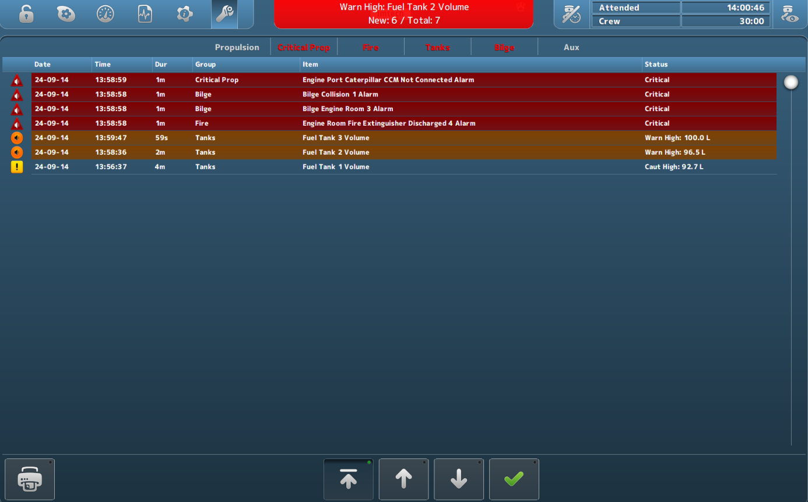

Figure 1‑25: Alarm mimic

Depending on which rights your station has, more or less buttons and/or alarm-information are shown.

The order will always be as follows:

* Critical alarms
* Warnings
* Cautions
* Time of appearance

So the latest *critical alarm* will always be on top. The latest *warning* will always be on top, after all *critical alarms.* Similarly, the latest *caution* will always be on top after all *critical alarms* and/or *warnings*.

#### Alarm icons

The alarm icons have distinctive colors and symbols, so you can see exactly what is going on with each alarm. A brief explanation of each icon is shown in the following table.

|  |  |
| --- | --- |
| **Icon** | **Explanation** |
|  | Critical alarm: Unacknowledged |
|  | Critical alarm: Silenced |
|  | Critical alarm: Acknowledge not allowed |
|  | Critical alarm: Acknowledged |
|  | Critical alarm: Rectified |
|  | Critical alarm: Transferred |
|  | Warning: Unacknowledged |
|  | Warning: Silenced |
|  | Warning: Acknowledge not allowed |
|  | Warning: Acknowledged |
|  | Warning: Rectified |
|  | Warning: Transferred |
|  | Caution: Unacknowledged |
|  | Caution: Silenced |
|  | Caution: Acknowledge not allowed |
|  | Caution: Acknowledged |
|  | Caution: Rectified |
|  | Caution: Transferred |

Table 5: Alarm Icons

The bottom of the alarm mimic houses buttons for printing and scrolling.



Figure 1‑26: Print button



Figure 1‑27: Up- down buttons

Upon clicking the *Print* button, you can print the alarm list (if a printer is available). With the *Up/Down* buttons you can scroll up, down or jump to the top of the list.

*The rest of the Alarm mimic will be explained in Chapter 2 (Duty Alarm System) and in chapter 0 (Personnel Alarm).*

# Alarm System

## Introduction

The alarm system provides clear and unambiguous representation of all the alarms that take place at a certain time and present that on any screen that has the rights to show that alarm. There is a difference between the alarm system and the Duty alarm system. The alarm system shows all the alarms to all the stations with the specific rights. The Duty alarm system divides the (machinery) alarms to a station “on duty” in case of an unmanned machinery space.

## Alarm handling

Alarm handling is determined in a set of international rules by standardization organisations. These rules are visualized in Figure 2‑1.

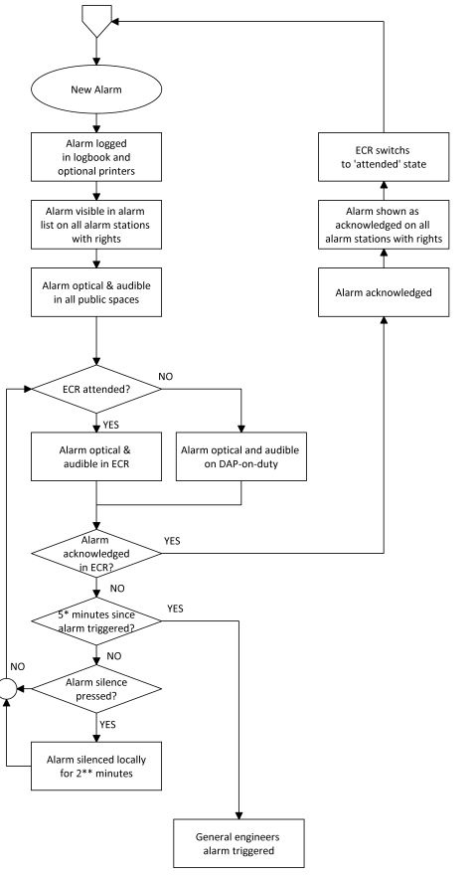

Figure 2‑1: typical alarm sequence

## Alarm handling in the alarm mimic

As shown in Figure 1‑25, all cautions, warnings and critical alarms will be shown in the taskbar and, more extensively, in the main window of the Alarm mimic. In *Table 5: Alarm Icons,* you will find the explanation of the various alarm icons and their meaning.

When you look further at the alarm mimic, you’ll notice more values and buttons. The row just above the alarm window (see Figure 2‑2), is the *alarm group row*. Depending on the alarm groups set here at initialisation of the system, you can see in which groups the alarms on the alarm page reside.



Figure 2‑2: Alarm group row

When even a single alarm within a group is active, the group label will turn red. This way you can see quickly in which group there are alarms.

When you click on this specific group label, the alarm mimic will be filtered to show only the specific alarms in that group. This will come in handy when you have a lot of alarms on the screen. After 10 seconds it will revert to the complete alarm list.

When you want to silence or acknowledge an alarm, you can double click on the alarm entry. Depending on the rights your station has, double-clicking will either silence, acknowledge or do nothing with the entry. Alternatively, you can click the silence/acknowledge-button (see Figure 2‑3) to silence/acknowledge all visible alarms in the alarm mimic. Depending on how many alarms you have, you will need to click one or more times to do this for all the alarms as this action only applies to the alarms currently visible on the screen.



Figure 2‑3: silence/acknowledge-button

### Explanation of alarm rights

During commissioning of the system, all stations will be set to their respective alarm station names with the distinctive rights set accordingly. Class demands that the only place where an alarm may be acknowledged is the space where you can act upon the alarm directly. This usually means that 99 percent of the alarms can only be acknowledged in either the engine room (ER) or the engine control room (ECR). For the other stations, the rules state that the alarms (if shown) can only be silenced. This means that the alarm stays unrectified and unacknowledged and only the buzzer will be silenced (at most for 3 minutes).



*If you are unable to acknowledge or silence alarms, you probably don’t have the rights.*

## Duty alarm system

The *Duty Alarm System* provides (machinery) alarms to bridge, cabins and public areas for an unattended (unmanned) machinery space. The duty alarm system is configured upfront.

*Duty Alarm Panels* (DAP’s, see Figure 2‑5) at specific locations are connected with the automation system via the LAN-network. They display the information for machinery alarms and settings such as alarm group status, operation status, and on-duty selection.

The duty alarm system provides for signaling of Engine Control Room (ECR) to the cabins and bridge by a *Duty Alarm Panel* (DAP) or on a *Local Operator Panel* (LOP).

An engineer on duty can be selected from the *Operator Workstation* (OWS). He will be warned when an critical alarm is present in the unmanned engine room.

An engineer can be called on duty from the ECR on the OWS. Each station has its own caller identification.

When no DAP is used, the duty alarm system can be implemented with small or larger hardware panels as shown in the following figures:

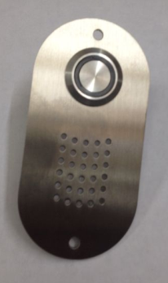 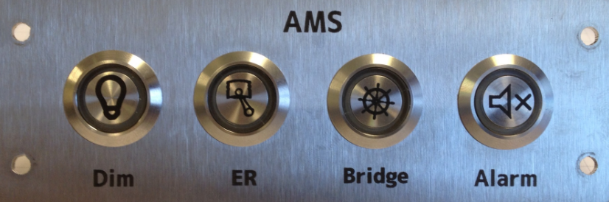

Figure 2‑4: typical Alarm panels

These panels come in the following editions, with their own respective operation.

|  |  |
| --- | --- |
| Panel horizontal-vertical | |
|  | |
|  | |
| Location of use: | Crew cabins that can be selected for Bridge duty as well as for ER duty |

|  |  |
| --- | --- |
| Panel horizontal-vertical | |
|  | |
|  | |
| Location of use: | Crew cabins that can be selected for ER duty |

|  |  |
| --- | --- |
| Panel horizontal-vertical | |
|  | |
|  | |
| Location of use: | Crew cabins that can be selected for bridge duty |

|  |  |
| --- | --- |
| Panel horizontal-vertical | |
|  | |
|  | |
| Location of use: | At each entrance door of the ER, or in the ECR |

|  |  |
| --- | --- |
| Panel horizontal-vertical | |
|  | |
|  | |
| Location of use: | Main or secondary bridge |

|  |  |
| --- | --- |
| Panel horizontal-vertical | |
|  | |
|  | |
| Location of use: | All spaces where Bridge duty crew can be available (no duty select) |

|  |  |
| --- | --- |
| **Button** | **Explanation** |
|  | Dim the button LED’s of that panel  Illuminates when panel is active |
|  | Silence the alarm  Illuminates when an alarm is active |
|  | No push activity  Illuminates when ER duty |
|  | No push activity  Illuminates when Bridge duty |
|  | Press for attended/unattended mode  Illuminates when attended |
|  | No push activity  Illuminates when timer is active |

Table 6: Alarm panel buttons

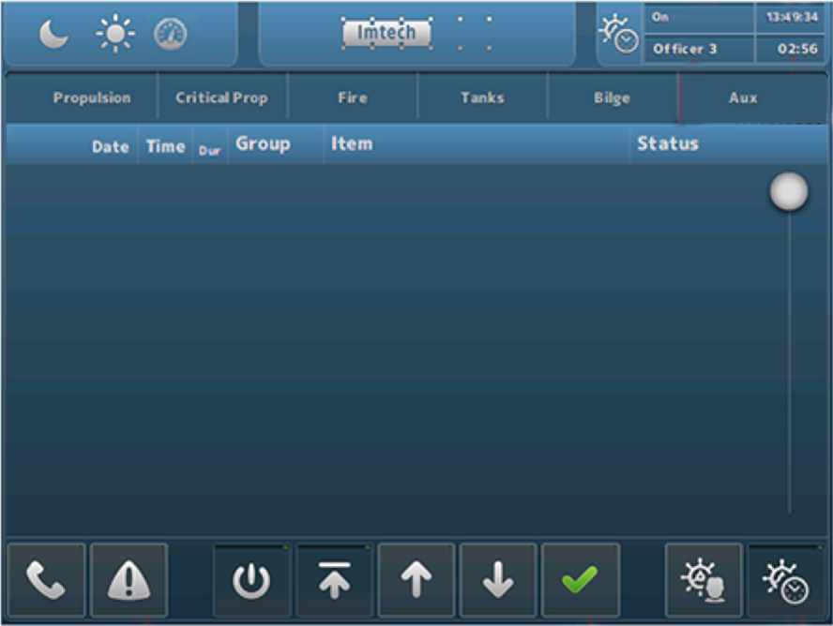

Figure 2‑5: Typical DAP screen

### Extra buttons alarm mimic

Depending if the station is set as a specific alarm station, some extra buttons will appear at the bottom of the alarm mimic. When the OWS is set-up as a bridge station, the icons as shown in Figure 2‑6 will appear. When the OWS is set-up as an ER station, the icons as shown in Figure 2‑7 will appear.



Figure 2‑6: Bridge set-up icons



Figure 2‑7: ER set-up icons

The meaning and handling of these icons are explained in the following table.

|  |  |
| --- | --- |
| **Button** | **Explanation** |
|  | Press to print (part of) the alarm list |
|  | Press and select space or crewmember to call |
|  | Switch station On/Off (when applicable) |
|  | Scroll to top |
|  | Scroll up |
|  | Scroll down |
|  | Acknowledge or silence alarms |
|  | Select crew for Bridge duty |
|  | Switch BNWAS On/Off |
|  | Select crew for ER duty |
|  | Switch personnel alarm On/Off |

Table 7: Alarm mimic set-up icons

The *Call* and *Duty Select* buttons have some additional choices, depending on who you can call or who you can select for duty. This will be configured upfront and will look as in Figure 2‑8 and Figure 2‑9. First select the *Call* or *Duty Select* button and then choose from the following menu.

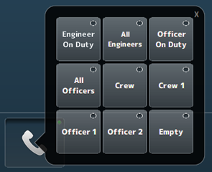

Figure 2‑8: Call function

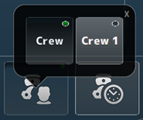

Figure 2‑9: Duty select function

Additionally, you can see the station that is calling you on the main screen (while hearing a buzzer tone if available). You can click on the message to make it disappear (see Figure 2‑10).

The person that is on duty will be visible on all stations in the right upper corner of the screen.

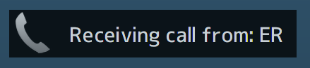

Figure 2‑10: receiving call message

Finally in the upper right corner of the alarm mimic some crew and time information will be shown (see Figure 2‑11). Here you can see if the ER is attended or unattended, who is on duty, the time and the timer (remaining time) from either the ER Personnel alarm or the BNWAS alarm.

The left button is the reset button for the timer. The right button is the same as the button *Switch station On/Off*.



Figure 2‑11: Crew information

### Duty alarm principal

The duty alarm system is used for the transfer of alarms to the technical crew in case of an unattended machinery space. The duty alarm system will be configured from a particular OWS. The duty alarm system provides unambiguous audio visual annunciation of alarms and warnings via a dedicated banner located at the top of the alarm panel screen.

A watch and call system extends the central alarm system to engineers' cabins and public areas when machinery spaces/control rooms are unattended.

### Alarm types

#### Alarm detection for analogue signals

The following functions are included:

* Instrument failure alarms
* Low-low process alarms with or without action (slow-down)
* Low process alarms
* High process alarms
* High-high process alarms with or without action (slow-down)
* Return to normal detection with dead-band to avoid alarm fluctuations
* Adjustable filter factors to filter fluctuations in the incoming signals
* Time delay of alarm triggering and return to normal messages.

#### Alarm detection for on/off (two state) signals

The following functions are included:

* High process alarms
* Return to normal detection
* Time delay of alarm triggering and return to normal messages.

#### Alarm detection for on/off signals with line check

The following functions are included:

* High process alarms (open or closed)
* Line broken alarm
* Line short alarm
* Return to normal detection
* Time delay of alarm triggering and return to normal messages.

### Attended alarm mode

NavVision will transfer the alarm to the activated location.

In case of an attended or manned machinery space this location will be the:

* Engine Control Room (ECR)
* Accommodations (e.g. mess room and public areas).

### Unattended alarm mode

In case the machinery space is left “unmanned”, alarms that will come in will be redirected immediately to the selected Duty Alarm Panel.

The “Unattended” mode can be activated on the workstation in de ER or the ECR.

NavVision will direct the alarm to the activated location.

In case of an unattended or unmanned machinery space this will be:

* The engineer on-duty
* Engine Control Room (ECR)
* Accommodations (e.g. mess room and public areas).

New alarms are indicated respectively on the DAP of the engineer on duty in the ER and in public spaces such as the mess room. On the panels, the alarm sounding (horn/buzzer) can be silenced (only local), but the alarms still need to be acknowledged on the OWS within the relevant technical area.

If alarms are not acknowledged within a specific period of time, the *General Engineers Alarm* (GEA) is invoked, independent from the *Attended/Unattended* mode. Once the GEA goes off, the alarm will sound on all alarm stations

## 

### How to acknowledge an alarm

The alarms must be acknowledged on the OWS in the Engine (Control) Room by means of:

* Double clicking the corresponding alarm line (alarm viewer)
* Click the Silence/Acknowledge button

### How to silence an alarm (not at ECR)

You can silence an alarm on all other locations (except GEA and Fire alarms).

This will silence the local alarm buzzer for 3 minutes, but will not acknowledge the alarm.

The engineer is required to go to the Engine (Control) Room to acknowledge the alarm.

### When will an alarm disappear

An alarm will disappear only when rectified AND acknowledged. Acknowledged alarms will show in the normal instrument colour.

# Personnel alarm

## Engineer Deadman

### Scope

The purpose of an Engineer Deadman System is to monitor engine room activity and detect engineer disability which could lead to marine accidents. The system monitors the awareness of the *engineer on duty* and automatically alerts another qualified engineer if for any reason the engineer on duty becomes incapable of performing his duties. This purpose is achieved by a series of indications and alarms to alert first the engineer on duty and, if he does not respond, then to alert another qualified engineer by means of a general alarm.

Additionally, the Engineer Deadman System may provide the engineer on duty with a means of calling for immediate assistance if required. The Engineer Deadman System should be operational whenever the engine room is attended and/or manned, unless inhibited by the Chief Engineer.

### The Engineer Deadman System incorporates the following operational modes:

* Manual ON (In operation when engine room is attended)
* Manual OFF (Does not operate under any circumstances)

*The Deadman timer can only be switched on or off by inserting a password. This to prevent illicit usage of the Deadman timer (see Figure 3‑1). Fill in the password and press enter, or the green checkmark to engage. The red “X” is to return.*

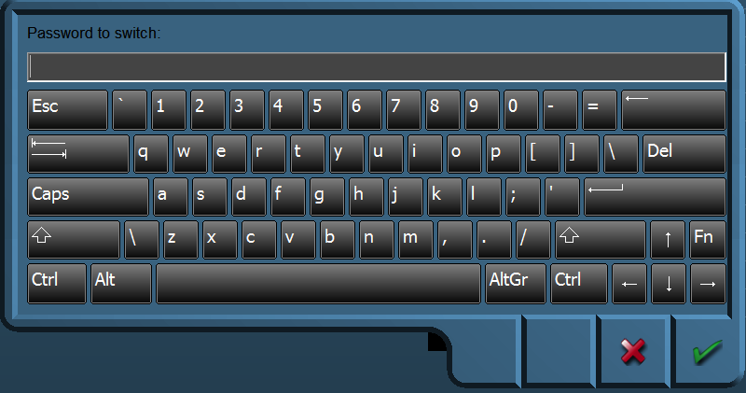

Figure 3‑1: Password entrance panel

### Operational State

Once operational, the alarm system remains dormant for a period of 30 minutes. At the end of this dormant period, the alarm system initiates a visual and audible indication on the AMS.

### Reset function

It is not possible to initiate the reset function or cancel any audible alarm from any device, equipment or system not physically located in areas of the engine room or ECR (local silence is allowed).

The reset function is only available in positions in the engine room and ECR. The reset function is easily accessible from the anywhere in the engine room.

The reset function cancels the visual indication and all audible alarms and initiates a further dormant period. If the reset function is activated before the end of the dormant period, the period should be re-initiated to run for its full duration from the time of the reset.

A continuous activation of any reset device triggers the emergency call facility within 3 seconds.

### Emergency call facility

Means are provided in the engine room to immediately activate the visual and audible alarm by means of an Emergency Call push button or similar. Holding any reset button for at least 3 seconds also triggers the emergency call facility.

## BNWAS

The BNWAS (Bridge Navigational Watch Alarm System) is a similar personal safety system, designed for use on the bridge.

### Introduction

It is possible that you use the BNWAS as a standalone version, but it can also be used in conjunction with the UniMACS bridge. It can even be used with other bridge systems as long as these systems give the standard EVE-messages.

In this manual, we will address both ways in the same explanation since their differences are mainly HMI-related and do not affect functionality.

When we discuss the interface of the BNWAS system, it can be the interface on the standalone BNWAS or on the integrated BNWAS. It can be the interface on the bridge-panel, but also the interface on the panel in the captain’s cabin. What follows is an integral explanation of the BNWAS functionality.

### The HMI overview

The HMI consists of a main screen that holds all functionality for the BNWAS and a setup-screen that can be used to enter the necessary settings. In the following figures, we will explain the functionality and functions on the HMI.

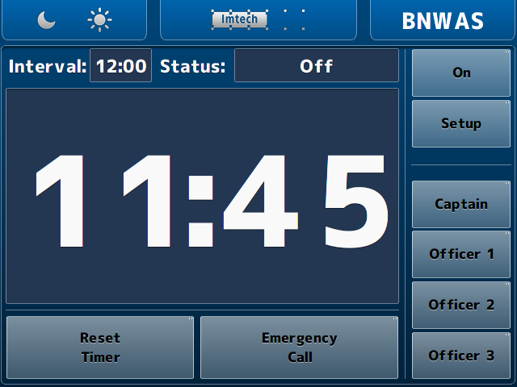

Figure 3‑2: Main BNWAS HMI

### The HMI explained

The functions of the HMI are described in the following figures. These are mostly self-explanatory. Where not explicitly clear, an additional explanation is given.

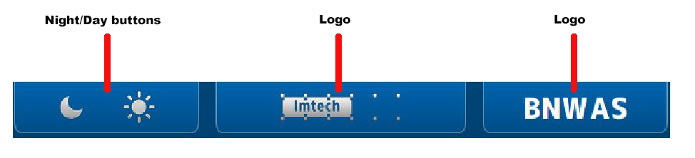

Figure 3‑3: HMI top bar

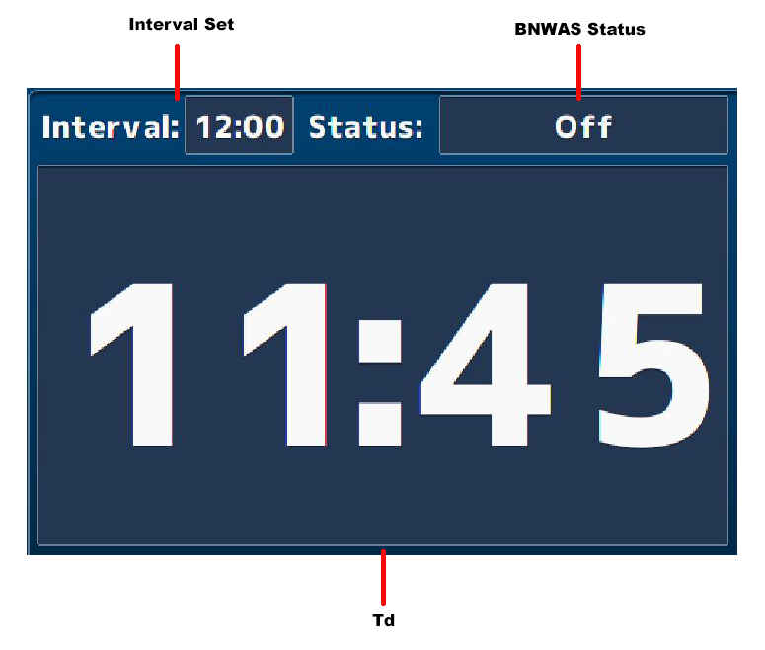

Figure 3‑4: HMI main screen

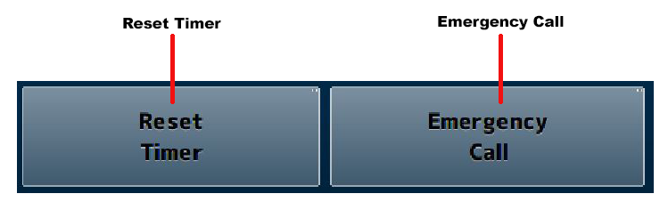

Figure 3‑5: HMI bottom bar

*The reset timer and emergency call buttons are only available when the panel is placed on the bridge. Any other location will show these buttons, but they will not be operational.*

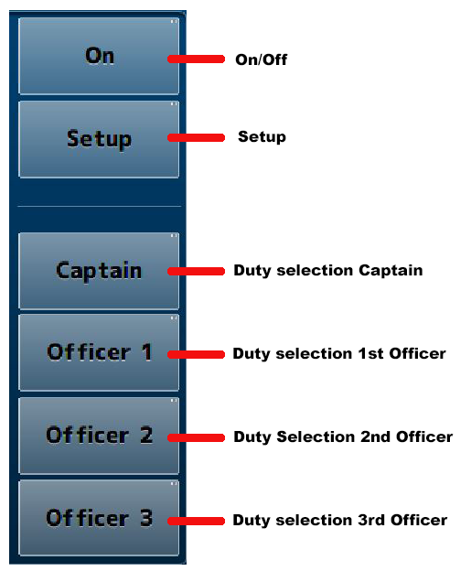

Figure 3‑6: HMI Panel

* When you operate the* On/Off *or* Setup *button a keypad will appear where you have to type a passcode. (See* Figure 3‑8*).*

### The setup page

By clicking on the setup button a new screen will appear. This is the setup screen. It looks quite the same as the main window as it has only a few settings in the main panel (see Figure 3‑9).

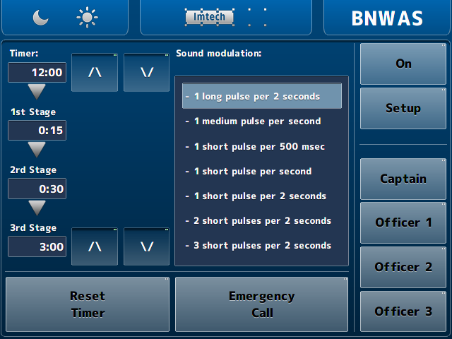

Figure 3‑7: Setup screen

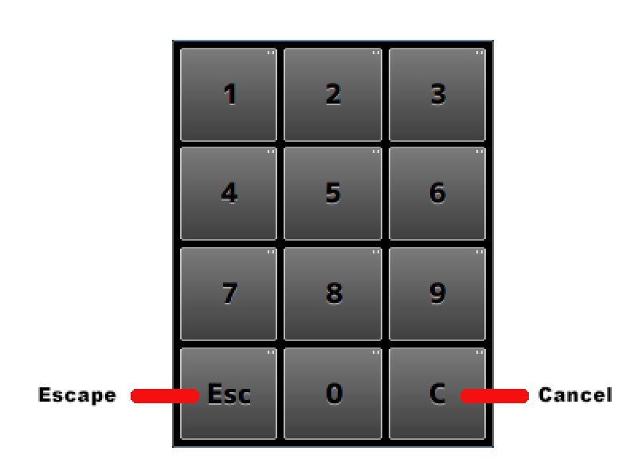

Figure 3‑8: Keypad

The functions, with their respective explanation, are shown in the following figure.

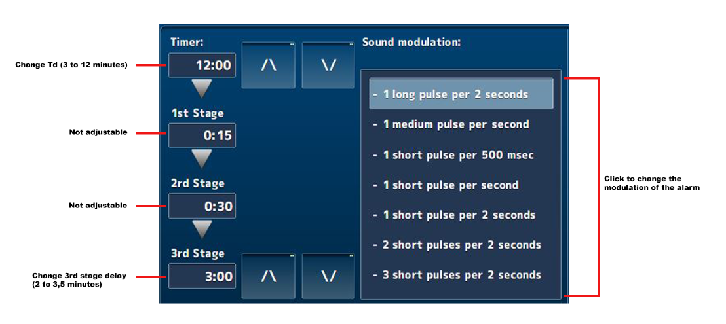

Figure 3‑9: Setup main screen

*With the arrow buttons in the setup page, you can increase or decrease the Td and/or 3rd stage delay time.*

Once a working NavVision server is connected to the same system, the HMI of NavVision will be overwritten on the DAP’s. It is just the HMI. The BNWAS will still be the one that handles all the BNWAS features.

It will look as in the following figure:

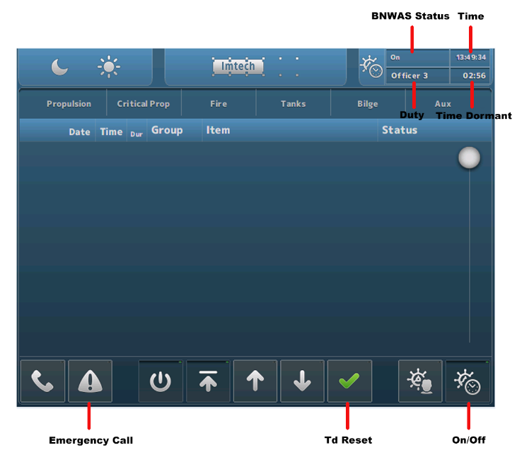

Figure 3‑10: NavVision HMI on DAP

On the NavVision server, you will have an equal kind of display as shown in the following figure.

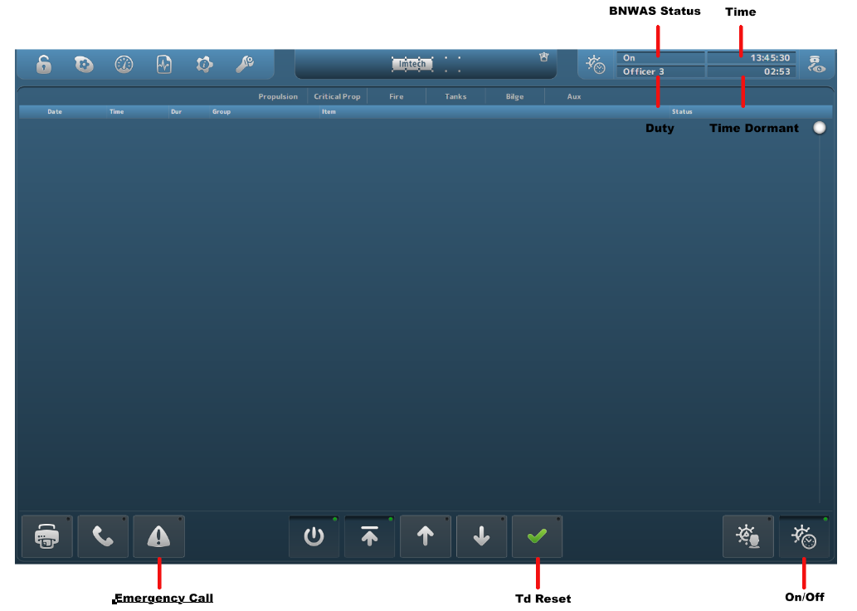

Figure 3‑11: NavVision Native screen

# Annex 1 Mimic control

Control elements are used to interface a wide range of *Control* devices like pumps, fans, valves, generators, etc. via their relevant starter unit. Since these element types are suitable to process a wide range of components, several symbols are defined to represent each type.   
Color animation is used to show the actual element status.

Chevrons, a single filled chevron (arrow) for low - and a double filled chevron (arrow) for high speed, show the difference between a control element running at high speed and a control element running at low speed. Chevrons without filling indicate an off condition.

## Mimic components

The mimic contains a lot of components which, together, make up for the representation of the ship or a specific system on the ship. Components can be some of the following different forms:

|  |  |
| --- | --- |
|  | Label |
|  | Icon |
|  | Value |
|  | Button |
|  | Horizontal Level |
|  | Vertical Level |
|  | Small Graph |
|  | Slider Control |
|  | Instrument |
|  | Indicator |
|  | Propulsion |
|  | DP View |
|  | Joystick |
|  | Propulsion |

## Component behaviour

Each component can have its own behaviour. Sometimes it is just representing a value and sometimes there is some extra functionality available. The following examples will give you an idea of some of the possibilities.

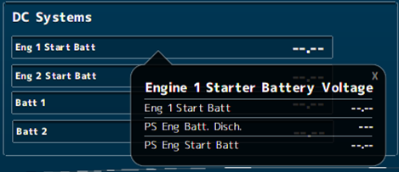

Figure 4‑1: Pop-up balloon

When you double-click on a value, a balloon will pop up with some additional information (see Figure 4‑1).

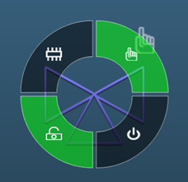

Figure 4‑2: control doughnut

When you click on items that you can control, a radial menu will appear. Depending on the element and its settings, you can control different aspects of the item (see Figure 4‑2). For the control elements, see Tables 8, 10, 11 and 12.

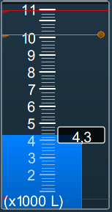

Figure 4‑3: Vertical bar with alarm lines

In the vertical bars (often used for tanks) you can see the warning and critical alarm levels. The critical alarm levels (red) are not changeable since these are mandated by class. The warnings (orange) can be changed by dragging the lines with your mouse on the little dot at the end of the line. This way, you can use it for example when filling a tank. You get a warning (visual and audible) when the warning line is crossed.

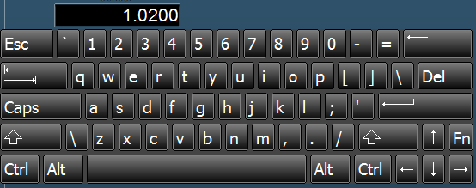

Figure 4‑4: Edit keyboard

When you have an *edit-enabled* value, you can click on it and a keyboard will appear (see Figure 4‑4). You can fill in an amount and press enter to change the desired value. It will not be possible to change it beyond the min/max values.

|  |  |  |
| --- | --- | --- |
| **Status** | **Control element** | **Symbol** |
| Operable in two speeds, system off | Double chevron (no fill) |  |
| Operable in two speeds, system running at low speed | Double chevron (single chevron filled) |  |
| Operable in two speeds, system running at high speed | Double chevron (double chevron filled) |  |
| Operation is disabled (local control only or controlled by other OPC) | Padlock |  |
| Manual operation (controlled remotely) | Hand |  |
| Automatic operation (controlled by ACS[1]) | Chip |  |

Table 8: Control element status

|  |  |
| --- | --- |
| **Colour** | **Description** |
| **Grey** | Control element off (stopped), device is ok |
| **Green** | Control element on (running), device is ok |
| **Orange** | Control element in warning condition |
| **Purple** | Control element defective |
| **Red** | Control element in alarm condition |

Pump and generator control elements

|  |  |  |  |
| --- | --- | --- | --- |
| **Centrifugal pump** | **Piston pump** | **Generator** | **Status description** |
|  |  |  | Off |
|  |  |  | On (condition ok) |
|  |  |  | On, warning condition |
|  |  |  | On,  defective condition |
|  |  |  | On,  critical condition |

Table 9: Control elements and color animation

|  |  |  |  |
| --- | --- | --- | --- |
| **3-way valve OFF** | **Status description** | **3-way valve ON** | **Status description** |
|  | 3-Way valve off (status indication only) |  | 3-Way valve on (status indication only) |
|  | 3-Way valve off, auto (control by AMCS[2]) |  | 3-Way valve on, auto (control by AMCS) |
|  | 3-Way valve off, auto  (local control) |  | 3-Way valve on, auto  (local control) |
|  | 3-Way valve off (local control) |  | 3-Way valve on  (local control) |
|  | 3-Way valve off, manual (controlled by AMCS) |  | 3-Way valve on, manual (controlled by AMCS) |
|  | 3-Way valve off, manual (local control) |  | 3-Way valve on, manual (local control) |

Table 10: Control elements with status indication

|  |  |
| --- | --- |
|  | Centrifugal pump on,  operable in two speeds, system off |
|  | Centrifugal pump on,  operable in two speeds, pump running at low speed |
|  | Centrifugal pump on,  operable in two speeds, pump running at high speed |

Table 11: Control elements with speed indication

|  |  |  |
| --- | --- | --- |
|  |  | Fan off & on |
|  |  | 2-way valve off & on |
|  |  | Check valve off & on |

Table 12: Other control elements

1.
2.